NARST 2021 INTERNATIONAL COMMITTEE
SCHOLARSHIP APPLICATION

REVIEW FORM

APPLICANT NAME:_________________________________________________

Criteria for eligibility:
In order to be eligible for the IC scholarship, the applicant should have “yes” response for the following items.

Yes | No
 |  | Applicant is a current member of NARST
 |  | Applicant resides outside of the US
 |  | Applicant is either a current graduate student or an early career researcher (within the 10 years of completion of Ph.D.)
 |  | Applicant provides evidence of participating in the Annual Conference (e.g., presenting a paper, participating with or chairing a committee, or serving on the Board, etc.)

Applicant’s country of residence:_____________________________________________

Criteria that Are Scored - SUMMARY TABLE
Applications will be scored based on the applicants stated need for support and merit in the field of science education research.

Evaluation Category | Points
Potential Contribution and Merit in Science Education Field
Nature of Participation at Conference
Expected benefits for attending conference
Contribution or Potential Contribution to Field (see CV)
Contribution Score
Need
Economy of country of work (Determine from Appendix A)
Applicant's statement of need
Need Score
TOTAL SCORE

RUBRIC 1 point for each following criterion

Criterion 1: NATURE OF PARTICIPATION ATANNUAL CONFERENCE
- Description of participation included all required information requires – title of presentation, seminar, or role/position in service to NARST (1 point)
- Description of participation provides a strong (2 pts.), fair (1 pt.), or weak (0pts) argument as to why their attendance at the conference is necessary.

Criterion 2: BENEFITS EXPECTED BY ATTENDING
- Applicant describes how attending the conference will benefit their own line of research and/or teaching. (1 point)
- Applicant describes how attending will benefit the goals of improving science education in their country of residence. (1 point)
- Applicant describes how their attendance may help with NARST’s overall goal of expanding as an international leader for promoting quality science learning and teaching globally. (1 point)

Criterion 3: SCHOLARLY CONTRIBUTIONS OR POTENTIAL CONTRIBUTIONS TO THE FIELD OF SCIENCE EDUCATION (refer to CV)

- Applicant’s CV demonstrates a strong record of scholarly research or activity through multiple publications, grants, and/or presentations at conferences. (3 points)
NOTE for assessors: Keep in mind that for graduate students a “strong record” may be shown more through collaborative work with advisors and conference presentations than actual publications and grants.
- Applicant’s CV demonstrates a good record in mainly one of following scholarly activities: publications, grants, and/or presentations at conferences. (2 points)
- Applicant’s CV demonstrates very limited record of any scholarly activities, such as: publications, grants, and/or presentations at conferences. (1 point)
- Applicant’s CV did not include any scholarly activities listed. (0 points)

CRITERION 4: Economy of country of work (Determine from Appendix A)

Low income (4 pts)

Lower middle income (3 pts)

Upper middle income (2 pts)

Higher income (1 pt)

CRITERION 5: Applicant's statement of need

Describes:

zero additional funding available (3 pts)

some additional funding (2 pts)

significate additional funding (1 pt)

describes having funds to cover participation without this award (0 pts)

Overall Comments
(please provide additional comments here)
APPENDIX A
(Economy of applicant's country of work is determined by the following charts published annually at https://datahelpdesk.worldbank.org/knowledgebase/articles/906519-world-bank-country-and-lending-groups)

Low-income economies ($1,035 or less)
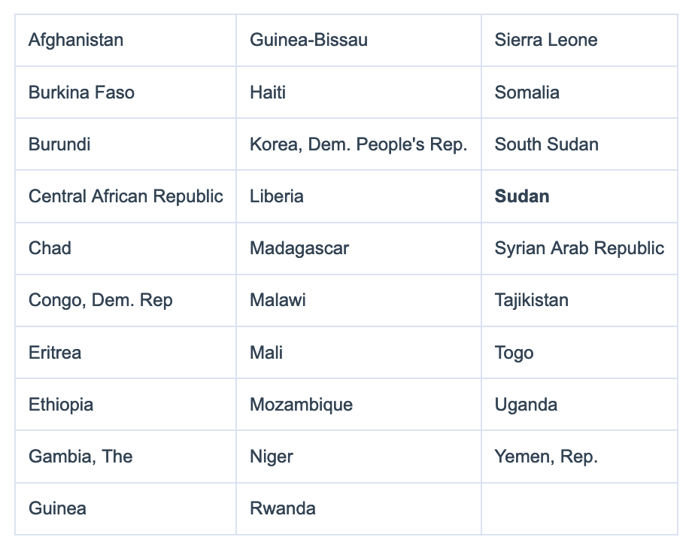

Lower-middle-income economies ($1,036 to $4,045)
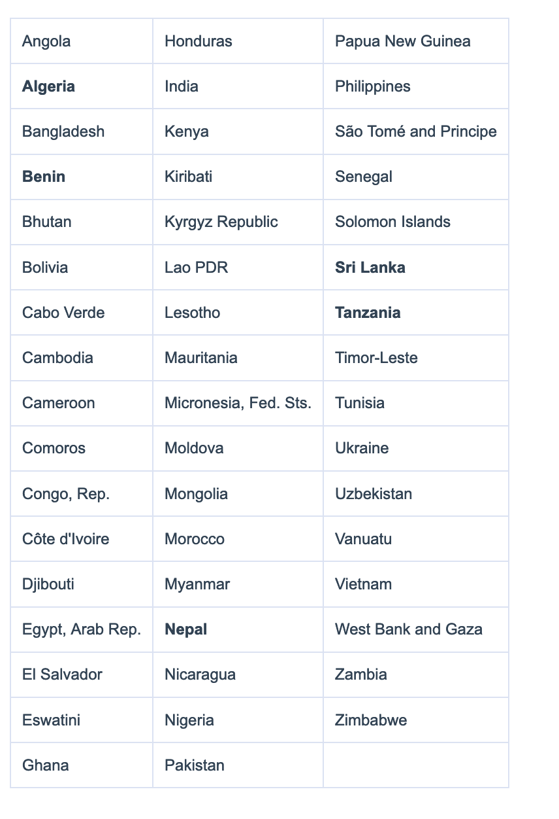
Upper-middle-income economies ($4,046 to $12,535)
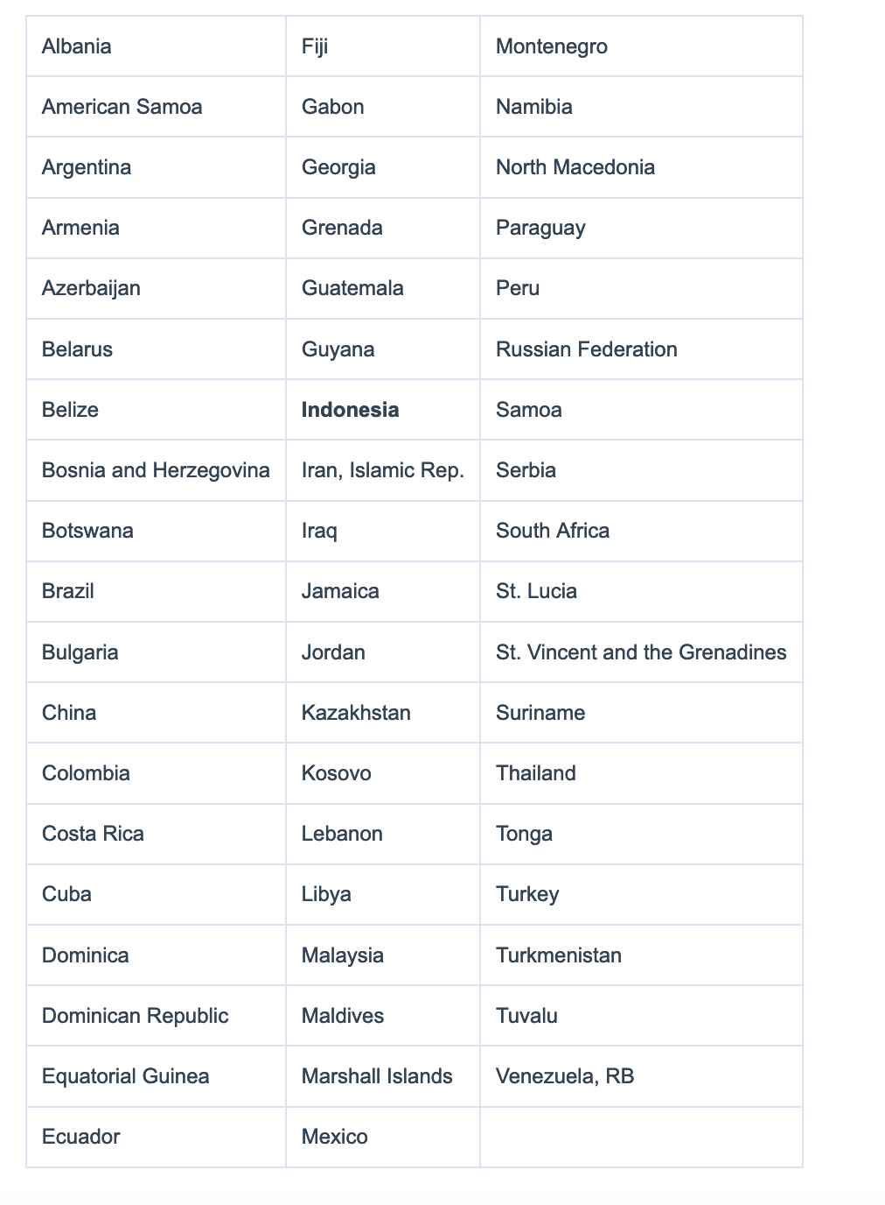

High-income economies ($12,536or more) 